1.Write a query to display the policytypeid,policytypename,description of all the car’s policy details.

Ans : Query

select s.policy_type_id , q.policy_type_name,s.description from

insurancedb.policy_sub_types s join insurancedb.ref_policy_types q on

s.policy_type_code=q.policy_type_code where q.policy_type_name='car';

Output:

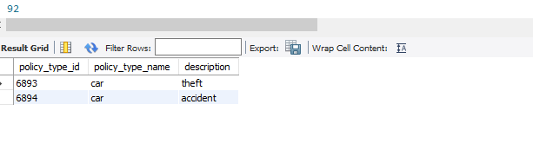

2.Write a query to display the policytypecode,no of polycies in each code with alias name NO_OF_POLICIES.

Ans:

select p.policy_type_code , count(*) as NO_OF_POLICIES from insurancedb.policy_sub_types p group by p.policy_type_code;

output:

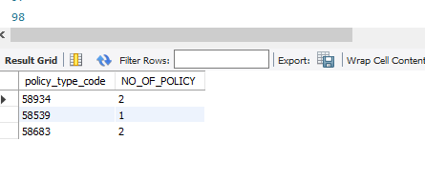

3.Write a query to display the userid,firstname,lastname, email,mobileno who are residing in Chennai.

select p.user_id, p.firstname, p.lastname, p.email, p.mobileno from insurancedb.user_details as p

join insurancedb.address_details as q on p.address_id = q.address_id where q.city='chennai';

output:

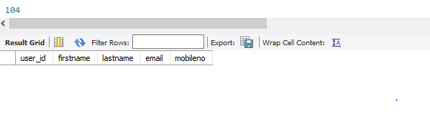

4.Write a query to display the userid, firstname lastname with alias name USER_NAME,email,mobileno who has taken the car polycies.

select p.user_id, concat(p.firstname, p.lastname) as USER_NAME, p.email, p.mobileno from insurancedb.user_details p join insurancedb.user_policies q on q.user_id = p.user_id

join insurancedb.policy_sub_types t on q.policy_type_id = t.policy_type_id

join insurancedb.ref_policy_types r on t.policy_type_code = r.policy_type_code where r.policy_type_name = 'car';

output :

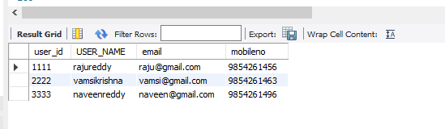

5.Write a query to display the userid, firstname,last name who has taken the car policies but not home ploicies.

select p.user_id, p.firstname, p.lastname from insurancedb.user_details p inner join insurancedb.user_policies q on q.user_id = p.user_id

inner join insurancedb.policy_sub_types t on q.policy_type_id = t.policy_type_id

inner join insurancedb.ref_policy_types r on t.policy_type_code = r.policy_type_code where r.policy_type_name = 'car' and r.policy_type_name not in ('home');

output:

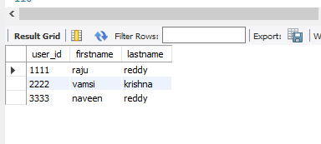

6.Write a query to display the policytypecode, policytype name which policytype has maximum no of policies.

select p.policy_type_code, p.policy_type_name from insurancedb.ref_policy_types p join

insurancedb.policy_sub_types q on p.policy_type_code = q.policy_type_code

group by p.policy_type_code, p.policy_type_name

having count(*) = (select MAX(policy_count) from (select count(*) as policy_count from

insurancedb.ref_policy_types p join insurancedb.policy_sub_types q on p.policy_type_code = q.policy_type_code

group BY p.policy_type_code, p.policy_type_name

) as counts

);

Output:

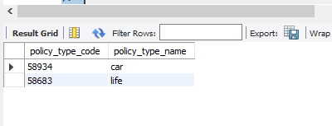

Or

select p.policy_type_code, r.policy_type_name from insurancedb.policy_sub_types p

join insurancedb.ref_policy_types r on p.policy_type_code= r.policy_type_code

group by p.policy_type_code , r.policy_type_name

order by count(*) desc Limit 1;

output :

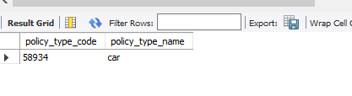

7.Write a query to display the userid, firtsname, lastname, city state whose city is ending with ‘bad’.

select p.user_id, p.firstname, p.lastname, q.city, q.state from insurancedb.user_details as p

join insurancedb.address_details as q on p.address_id = q.address_id where city like '%bad';

output:

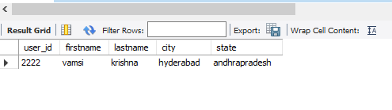

8.Write a query to display the userid, firstname, lastname ,ploicyno, dateregistered who has registered before may 2012.

select p.user_id, p.firstname, p.lastname, q.policy_no, q.date_registered from insurancedb.user_details as p

join insurancedb.user_policies as q on p.user_id = q.user_id where q.date_registered < '2012-05-01';

output:

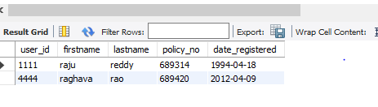

9.Write a query to display the userid, firstname, lastname who has taken more than one policies.

select p.user_id, p.firstname, p.lastname from insurancedb.user_details p join insurancedb.user_policies q on

p.user_id = q.user_id

group by p.user_id, p.firstname, p.lastname

having count(q.policy_no) > 1;

output:

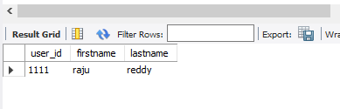

10.Write a query to display the policytypecode, policytypename, policytypeid, userid, ploicyno whose maturity will fall in the month of august 2013.

Ans:

select p.policy_type_code , r.policy_type_name, u.policy_type_id, u.user_id, u.policy_no

from insurancedb.policy_sub_types p

join insurancedb.user_policies u on u.policy_type_id = p.policy_type_id

join insurancedb.ref_policy_types r on r.policy_type_code = p.policy_type_code

where Year (u.date_registered) = 2030 and

month( u.date_registered) =8;

output:

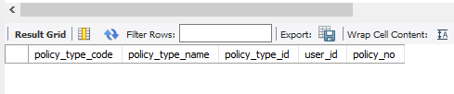

11.Write a query to display the userid, total amount paid by the customer with alias name total_amount.

Ans:

select p.user_id, SUM(q.amount) as Total_amount from insurancedb.user_details as p

join insurancedb.policy_payments as q on p.user_id = q.user_id

GROUP BY p.user_id;

Output :

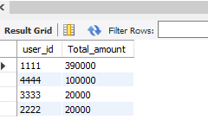

12.Write a query to display the user_id, policy_no, total amount paid by the customer for the each policies.

select p.user_id, p.policy_no, sum(q.amount) as total_amount from insurancedb.user_policies as p

join insurancedb.policy_payments q on p.policy_no=q.policy_no

group by p.user_id,p.policy_no;

output:

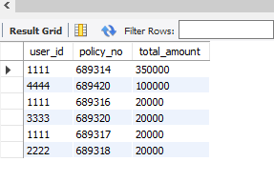

15.Write a query to display the user details userid,firstname,last who has taken car, home and life loans.

select p.user_id, p.firstname, p.lastname as USER_NAME, p.email, p.mobileno from insurancedb.user_details p inner join insurancedb.user_policies q on q.user_id = p.user_id

join insurancedb.policy_sub_types t on q.policy_type_id = t.policy_type_id

join insurancedb.ref_policy_types r on t.policy_type_code = r.policy_type_code where r.policy_type_name in ('car', 'life', 'home');

